Centro de Astrofísica da Universidade do Porto
Universidade de Lisboa, SIM/IDL & LOLS
INAF, Osservatorio Astronomico di Trieste
INAF, Osservatorio Astronomico di Brera
Observatory of the University of Geneva
Physics Institute, University of Bern
Instituto de Astrofísica de Canarias
European Southern Observatory

ESPRESSO

Fabry-Pérot Calibrator

Installation, Operating and Maintenance Manual

VLT-TRE-ESP-13520-9204, Draft

May 14th, 2016

Prepared F. Pepe 14/05/2016
Name Date Signature

Approved F. Zerbi
Name Date Signature

Released F. Pepe
Name Date Signature

Change Record
Issue/Rev. | Date | Section/Page affected | Reason/Remarks
Draft | 14/05/2016 | All | Prepared in view of Sub-system acceptance

Table of Contents
Chapter 1. Introduction 9
1.1 Scope of the Document 9
1.2 Documents 9
1.2.1 Applicable Documents 9
1.2.2 Reference Documents 9
1.3 Acronyms and Abbreviations 9
1.3.1 Acronyms 9
Chapter 2. General Requirements 11
2.1 General characteristics of the Fabry-Pérot Calibrator 11
2.2 Dimensioning of the Fabry-Pérot etalon 12
Chapter 3. Technical Requirements 13
3.1 Operational conditions 13
3.1.1 Atmospheric pressure 13
3.1.2 Temperature 13
3.1.3 Relative humidity 13
3.2 Performance requirements 13
3.2.1 Etalon requirements 13
3.2.2 Fabry-Pérot parameters 13
3.2.3 Delivered flux and flux homogeneity 13
3.2.4 Wavelengths stability 14
3.2.5 Line shape and line shape stability 14
3.2.6 Vacuum 14
3.2.7 Monitoring 14
3.2.8 Summary of performances requirements towards the FPC 14
Chapter 4. Design architecture 16
4.1 Product Tree of the RV-reference module 16
4.2 Primary source and spectral flux 17
4.3 Etalon parameters 19
4.4 Thermal control 19
4.5 Pressure sensor and controller 20
4.6 Summary of hardware devices 20
Chapter 5. Mechanical design 21
5.1 Overview 21
5.2 The vacuum tank 24
5.3 Optical feed-through 24
5.4 Fabry-Pérot assembly 24
5.5 The entrance fiber-holder spider 25
5.6 The parabolic mirror mounting 25
5.7 The etalon mounting 26
5.8 The exit fiber-holder spider 27
Chapter 6. Interfaces 28
6.1 Optical interface 28
6.2 Mechanical interface 28
6.3 Control system software interface 28
6.4 Hardware interfaces 28
Chapter 7. Performance Analysis 29
7.1 Spectral range and energy distribution 29
7.2 Finesse and spectral resolution 32
7.3 Line positions 33
7.4 Photonic Doppler precision content 34
7.5 Stability measurements 35
7.5.1 Drift computation and use of new algorithm 35
7.5.2 Short-term stability 36
7.5.3 Long-term stability 37
7.5.4 Wavelength dispersion and local accuracy 38
7.6 On-sky tests and operations 39
7.6.1 Description of operations 39
7.6.2 Observations of known standards 40
Chapter 8. Compliance matrix 42
Chapter 9. Conclusion 45
Chapter 10. Appendix 46
10.1 Data sheets 46

List of Figures
Figure 1: Functional diagram of the RV reference unit 16
Figure 2: EQ99 light source and lamp controller 17
Figure 3: Spectral power distribution of the LDLS source. 18
Figure 4: Internal transmission of the FPC fibers 18
Figure 5: Heat-blocking filter TKG – 5253 transmittance 18
Figure 6: Internal transmission of Infrasil Fused Silica 19
Figure 7: Lakeshore 335 Temperature Controller 19
Figure 8: MPT vacuum gauge (right) and its DPG109 controller (left) 20
Figure 9: Section view of the Fabry-Pérot 23
Figure 10: Ouside view of the vacuum vessel 24
Figure 11: Fiber-optical vacuum feed-though 24
Figure 12: General view of the FPC opto-mechanical assembly 25
Figure 13: View of the upper spider and fiber support 25
Figure 14: Section view of the parabolic mirror and its support 26
Figure 15: Section view of the etalon and its support 26
Figure 16: Section view of the upper spider and fiber support 27
Figure 17: FPC currently in use on HARPS-N during the tests (left) and in its isolation box (right) 29
Figure 18: Fabry-Pérot etalons produced by ICOS. Left: Pure Zerodur-spacers etalon of low CTE. Right: Compensated spacers for theoretical zero CTE 29
Figure 19: Top: Raw HARPS frame of the FPC spectrum illuminating both fibers. Bottom: For comparison, a frame is shown in which one of the fiber was illuminated with the thorium lamp. Note the richness of the FPC spectrum compared to that of the thorium. 30
Figure 20: Left: Transmission spectrum of the Fabry-Pérot etalon averaged of a broad band (>> than a typical FSR of the etalon). Right: flux at the peak of a transmission line of the FP when illuminated by the Xe-lamp compared to the tungsten lamp. Measurements have been carried out with HARPS. 31
Figure 21: Peak flux of the FPC as a function of echelle order (from 690 nm, left, to 380 nm, right) 31
Figure 22: Direct measurement of the FP transmittance when varying the optical gap 32
Figure 23: Zoom on the FP raw spectrum as recorded by the HARPS spectrograph and portion of the extracted 1-D spectrum 33
Figure 24: Ratio of line separation to line width over the full wavelength range of the HARPS spectrograph. Order nr. 1 corresponds to 383 nm while order nr. 70 is located at about 680 nm. At short wavelengths some noise is introduced by the low flux. Within a single order the dispersion of the measured finesse is due to the varying dispersion of the echelle spectrograph along the order. 33
Figure 25: Effective etalon gap 2D(λ) as a function of wavelength and is difference from the nominal value of 14.6 mm 34
Figure 26: Fundamental (photon-noise limited) precision obtained on a single FP spectrum. The results from the thorium lamp are shown for comparison. 35
Figure 27: Relative drift measurements over 7 hours to test the short-term performances of the FPC 36
Figure 28: Absolute drift measurements over 7 hours to test the short-term performances of the FPC 37
Figure 29: Drift measurements over 180 days to test the long-term performances of the FPC 38
Figure 30: Dispersion law of the FPC (expressed in effective etalon gap) recorded over two seasons separated by more than one year. Left: full wavelength range of HARPS. Right: Zoom over a single order. 38
Figure 31: Dispersion variation (expressed in difference of effective etalon gap) between two seasons separated by one year as a function of wavelength. Left: full wavelength range of HARPS. Right: Zoom over a single order. 39
Figure 32: Observations of the star HD 85512 over a ten-days period with the simultaneous reference technique using the ThAr (red) and the FPC (blue). Radial-velocities are identical, although the dispersion seems to be even a little bit lower when using the FPC. 41
Figure 33: Observations of the star HD 128621 (alpha Cen B) over a ten-days period with the simultaneous reference technique using the FPC (blue) and without any simultaneous reference at all. radial-velocities are identical, indicating that the FPC work well even on bright objects and that it does not introduce any systematic offset or error. 41
Figure 34: 10 years of Tau Ceti demonstrating the long-term stability of the ThAr calibration. 44

List of Tables
Table 1: Requirements towards the FPC 15
Table 1: FPC hardware devices 20
Table 2: Compliance matrix 42
Table 4: Requirements towards the FPC 43

Introduction

Scope of the Document
This document describes installation, operation and maintenance of the ESPRESSO FPC. It is a draft prepared for the sub-system acceptance and it shall be updated for PAE and after Commissioning. Furthermore. it is intended to be integrated into the ESPRESSO User Manual.

Documents
The applicable and reference documents are listed below:

Applicable Documents
 | ESPRESSO Statement of Work | VLT-SOW-ESO-13520-5059 | 1 | 01.02.2011
 | ESPRESSO Technical Specifications | VLT-SPE-ESO-13520-4633 | 3 | 01.02.2011

Reference Documents

 | Fabry-Pérot Calibrator Final Design Description and Performances Analysis | VLT-TRE-ESP-13520-0154 | 2 | 04.05.2016
 | Fabry-Pérot Calibrator Product Tree | VLT-LIS-ESP-13520-9201 | 1 | 04.05.2016
 | ESPRESSO – Paranal Observatory ICD | VLT-ICD-ESO-13529-5412 | 3 | 28.11.2014

Acronyms and Abbreviations

Acronyms
AD Applicable Document
AIV Assembly, Integration and Verification
CCL Combined Coudé Laboratory (of the VLT)
CIDL Configuration Items Data List
CTE Coefficient of Thermal Expansion
E-ELT European Extremely Large Telescope
ESO European Southern Observatory
ESPRESSO Echelle Spectrograph for Rocky Exoplanets and Stable Spectroscopic Observations
FDR Final Design Review
FP Fabry-Pérot (etalon)
FPC Fabry-Pérot Calibrator
FWHM Full-Width at Half Maximum
HW Hardware
ICD Interface Control Document
ICS Instrument Control Software
ISO International Organisation for Standardisation
IP Instrumental Profile
LDLS Laser-Driven Light Source
LFC Laser-Frequency Comb
LRU Line-Replaceable Unit
MTBF Mean Time Between Failures
N/A Not Applicable
PAC Provisional Acceptance Chile
PAE Provisional Acceptance Europe
PDR Preliminary Design Review
PI Principal Investigator
PLC Programmable Logic Controller
PM Project Manager
QA Quality Assurance
RAMS Reliability Availability Maintainability Safety
RD Reference Document
RfW Request for Waiver
RV Radial Velocity
SOW Statement Of Work
SW Software
TBC To Be Confirmed
TBD To Be Defined/To Be Developed
ThAr Thorium-Argon (lamp)
ULE Ultra-Low Expansion (material)
UPS Uninterrupted Power Supply
UT Unit Telescope (8.2 meter telescope at Paranal)
VLT Very Large Telescope
VM Verification Matrix
WBS Work Breakdown Structure
WP Work Package

Packing list
The detailed Product Tree of the FPC is given in RD-2. For shipment and delivery the packaging is done accordining to the following packing list:
- FPC Cabinet: One reusable box made containing the FPC cabinet and its whole content>
width x depth: TBD cm x TBD cm
height : TBD cm
weight: TBD kg full, TBD kg empty
- FPC cables and fibers: One reusable corrugated paperboard box for the electronic cables and the optical fibers
width x depth: TBD cm x TBD cm
height : TBD cm
weight: TBD kg full, TBD kg empty
- FPC LDLS and Lakeshore: The LDLS assembly and temperature controller, installed in the Thermal Cabinet.

Shipping instructions
The FPC system is shipped in the configuration described above. During the whole shipping process, following instructions must be followed and guaranteed:
- The shipping boxes must be isoltated against humidity with termafoil.
- For the shipping the FPC is be kept under vacuum, starting with operational vacuum (typically <10⁻³ mbar) and slowly outgassing.
- Shocks must be avoided, especially when handling the box with the opto-mechanical system
- The box with the opto-mechanical system and the box with the control electronics must be kept vertical at all times.

Unpacking

FPC Cabinet
- Unscrew the top panel of the FPC Cabinet box
- Unscrew the front side panel of the box (one of the 2 narrow panels)
- Remove the top packing material to gain access to the thermal container grips
- Open the yellow strap
- Carefully lift the cabinet out of the box and put it on its wheel on flat, even ground
- Roll it to its operating location and strap it in place
Figure 1: FPC Cabinet on its transportation wheels
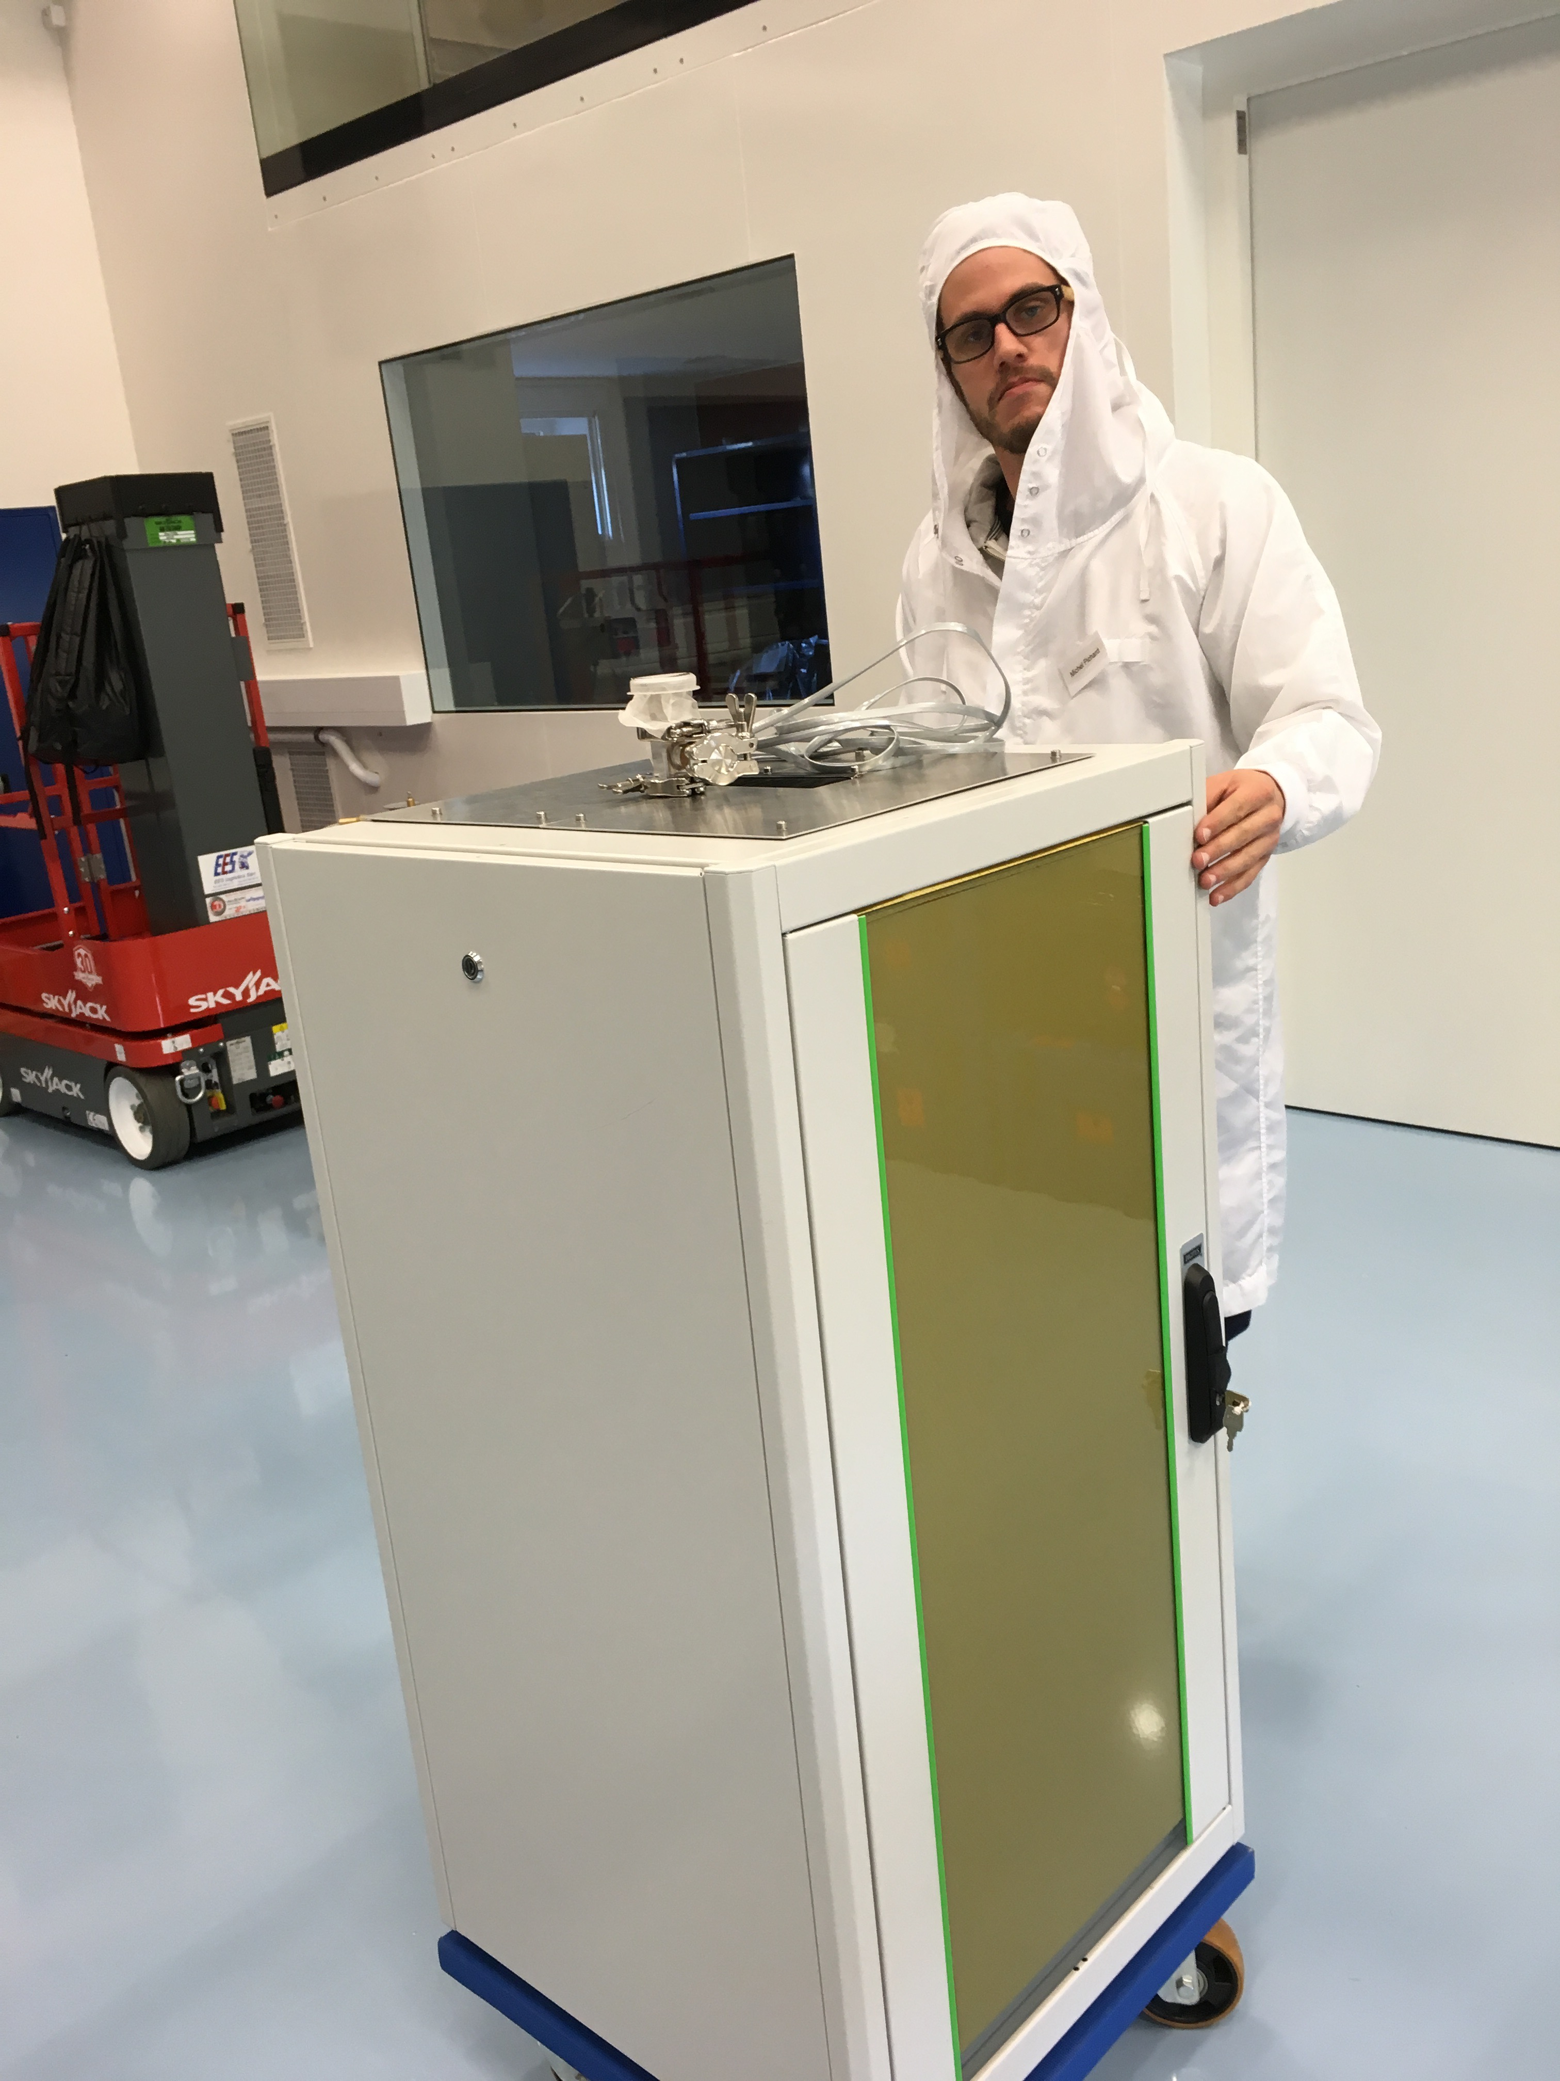

FPC Cables and Optical Fibers
- Open the box only once the FPC cabinet and the Thermal Cabinet are definitively installed in their final location. Cut open the tape holding the fibers box closed
- Carefully open the ties holding the cables and fibers in place.
- Take out the cables and fibers as you need them. Do not disconnect the fibers that are possibly already connected together.

FPC LDLS and Lakeshore
- The LDLS and the Lakeshore controller are definitively installed in the Thermal Cabinet.
- Do not remove fibers or un-mount any component unless explicetly requested in the installation instructions.
- Do not open the LDLS Xe light source (cube), align its mirror, or disconnect the optical fiber connecting the laser with the Xe light source.

Installation and Connections

Installation
- Install Themal Cabinet in its final position in accordance with RD-3 and as shown in Figure 2.
- Install the FPC Cabinet in its final position in accordance with RD-3 and as shown in Figure 2.
Figure 2: Configuration of ESPRESSO and location of the FPC inside VLT's Combined Coudé Laboratory
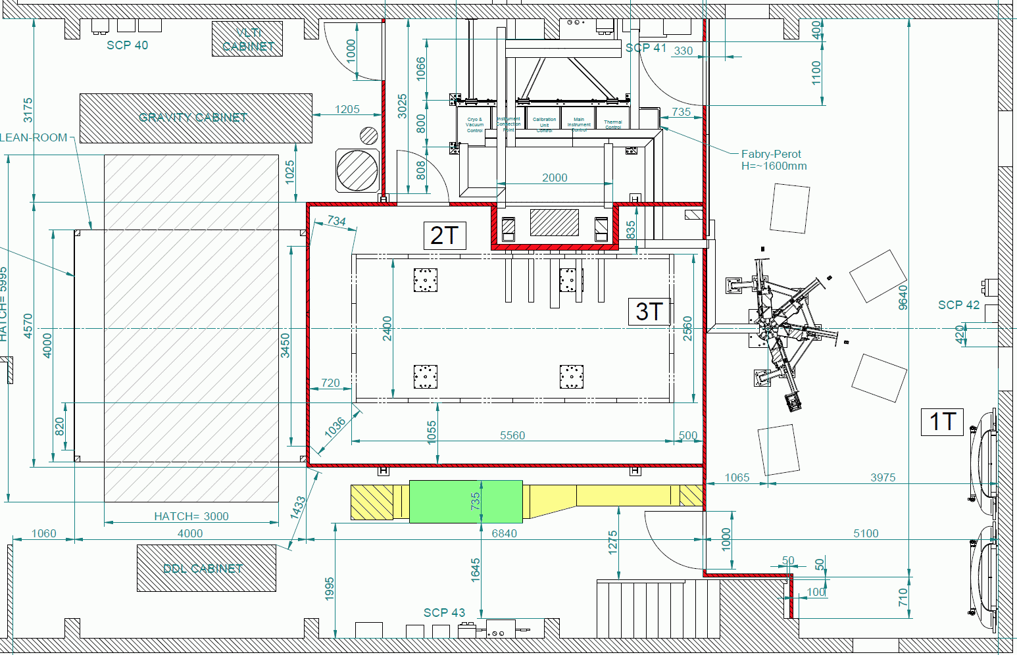

Installation and connection of the LDLS light source and the Lakeshore controller
In principle, the Lakeshore controller and the LDLS light source is already installed and connected within the Thermal cabinet. Nevertheless, connection instructions are given below in case the LDLS had to be dismounted for corrective mainetance or access:
- Connect the AC power cable of the Lakeshore temperature controller to an UPS Plug on the Thermal Cabinet
- Connect the AC power cable of the LDLS controller to an UPS Plug on the Thermal Cabinet
- Connect the 12V DC power cable between the LDLS controller and the Laser
- Connect the I/O-control cable between the LDLS controller and the Laser (may change with operation)
- Connect the ‘LAMP’ cable between the Laser and the Xe-Source
- The metal-jacket protected optical fiber between the Laser and the Xe Source MUST ALWAYS remain connected! Once deconnected it can only be cleaned and aligned by experts!
- Connect the 100 cm 230 µm fiber between the Xe Source and the Filter Box.
Figure 3: LDLS lamp assembly in the Themal Cabinet
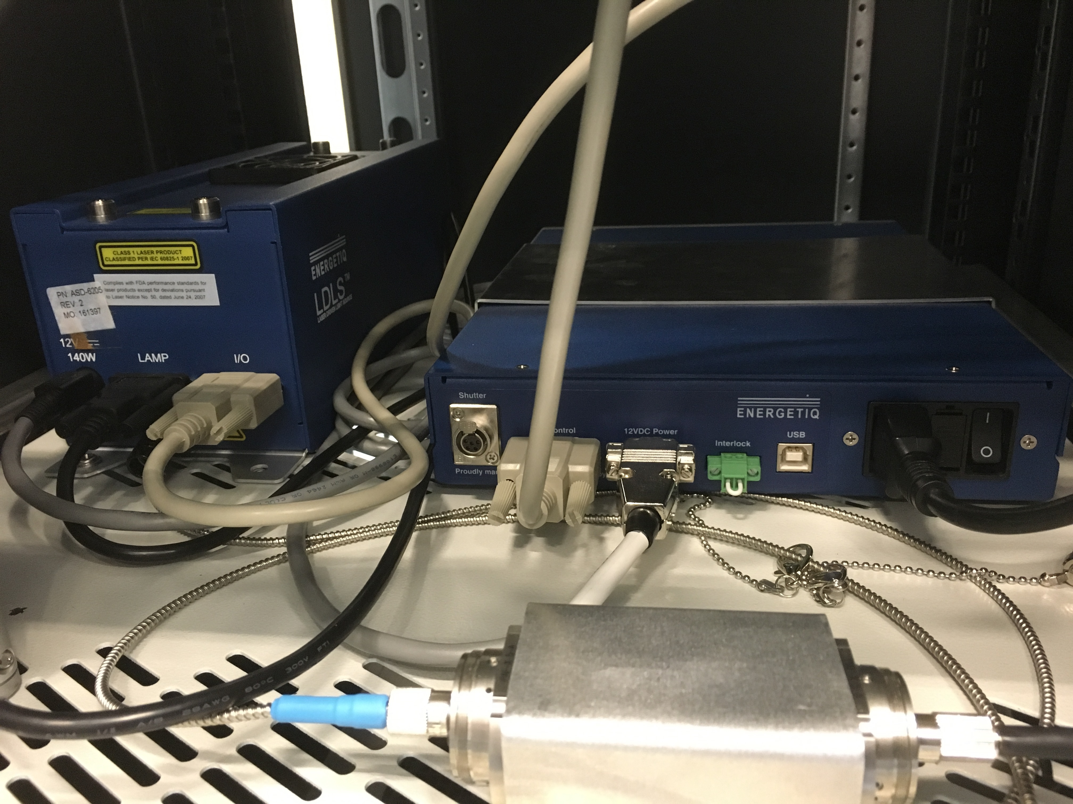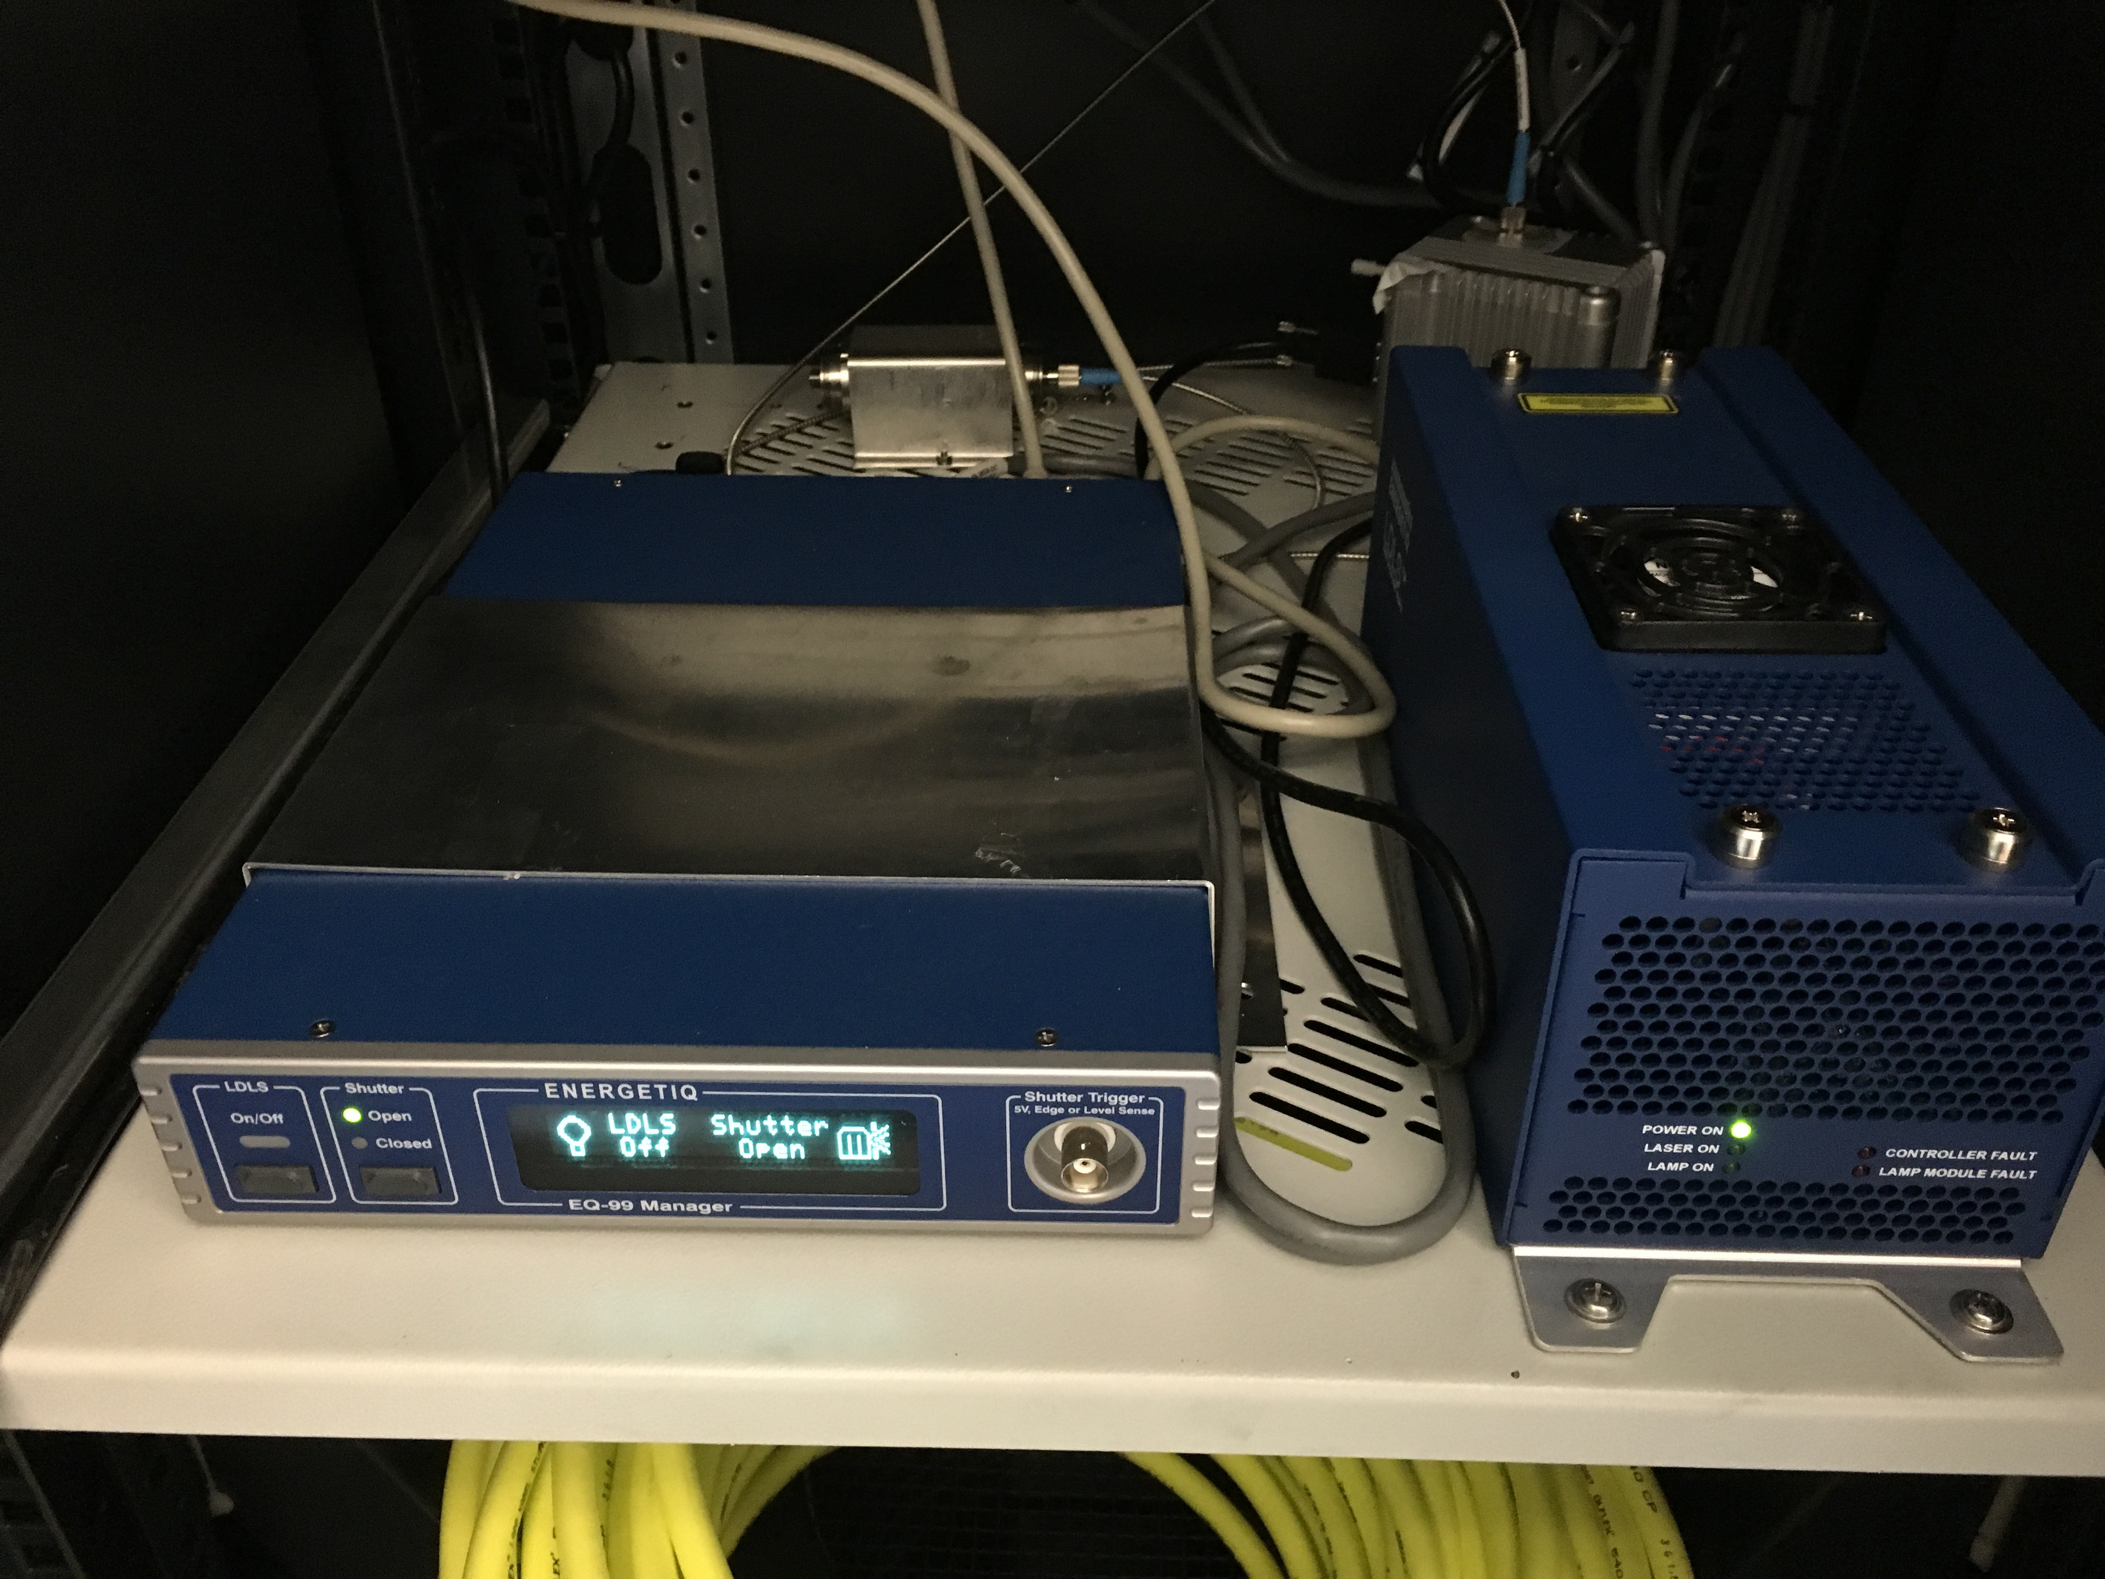

Connection of cables and fibers
- Open the top of the FPC cabinet and remove isolations (Figure 8)
- Connect the special electrical cable from the Lakeshore Controller to the FPC cabinet. On the Lakeshore controller side, connect sensors to inputs C and D and the heater to output 2 (Figure 5). On the FPC side connect sensors to military connector and heater cable to special XX connectors. (Figure 7)
- Connect the orange 5-m 200µm thorlabs fiber from the output of the Filter Box (Figure 6) to the input-fiber port (200µm feed-through) of the FPC (Figure 7). Follow the foreseen cable trays for this purpose and fix the fiber safely.
- On the FPC side connect the single end of the black 7-m 2 x 300µm Y- cable to the output-fiber port (600µm feed-through) of the FPC (Figure 7). On the Calibration-Unit Cabinet, connect the two ends of the black 7-m 2 x 300µm Y- cable to the corresponding input ports of the Calibration Unit (Figure 8). Follow the foreseen cable trays for this purpose and fix the fiber safely.
- On the FPC side connect the 10-m long RJ-45 cable to the back of the vacuum gauge (Figure 8). On the Cryo- and Vacuum control cabinet, connect the 10-m long RJ-45 cable to the corresponding PLC module (Figure 10). Follow the foreseen cable trays for this purpose and fix the cable safely.

Figure 5: Back-side of the Lakeshore Controller
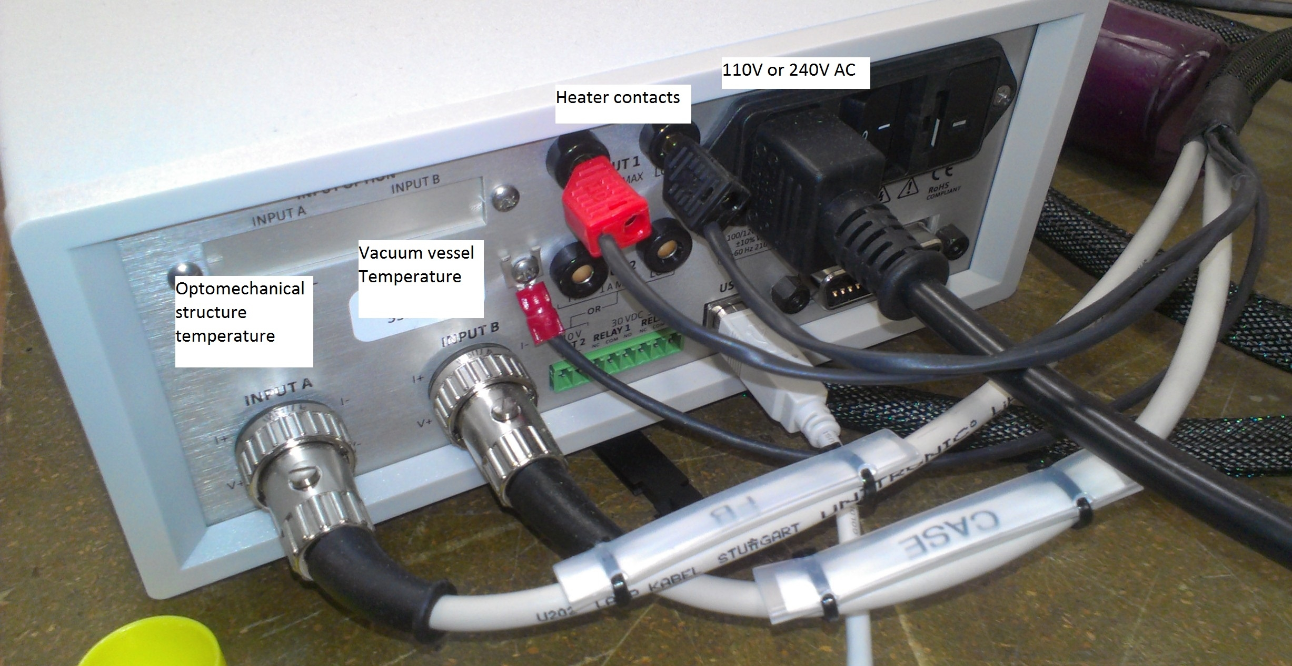

Figure 6: LDLS and Filter Box
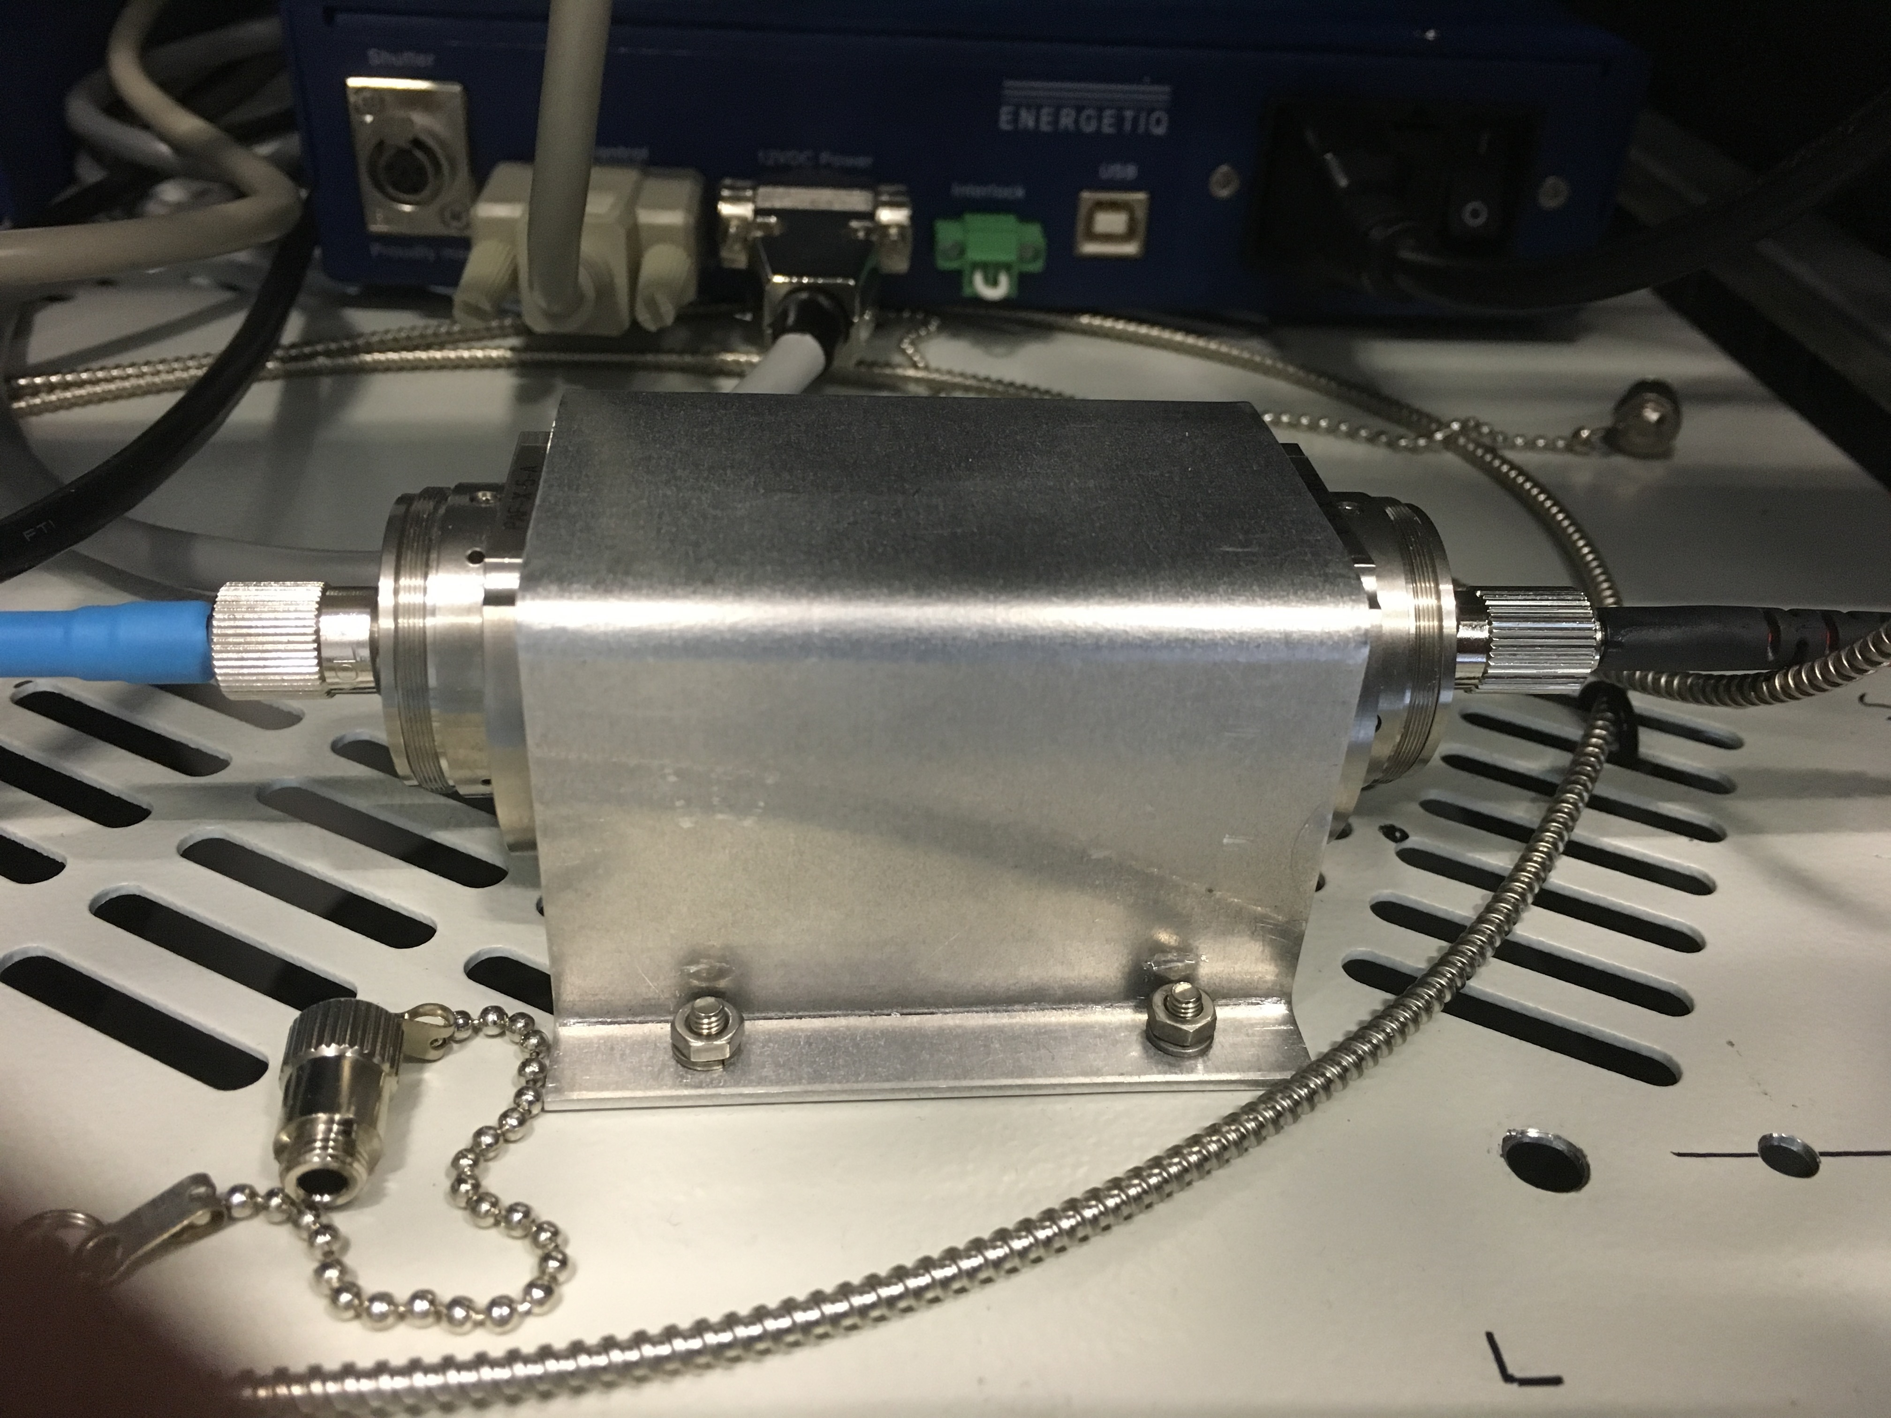

Figure 7: Top-view of the FPC
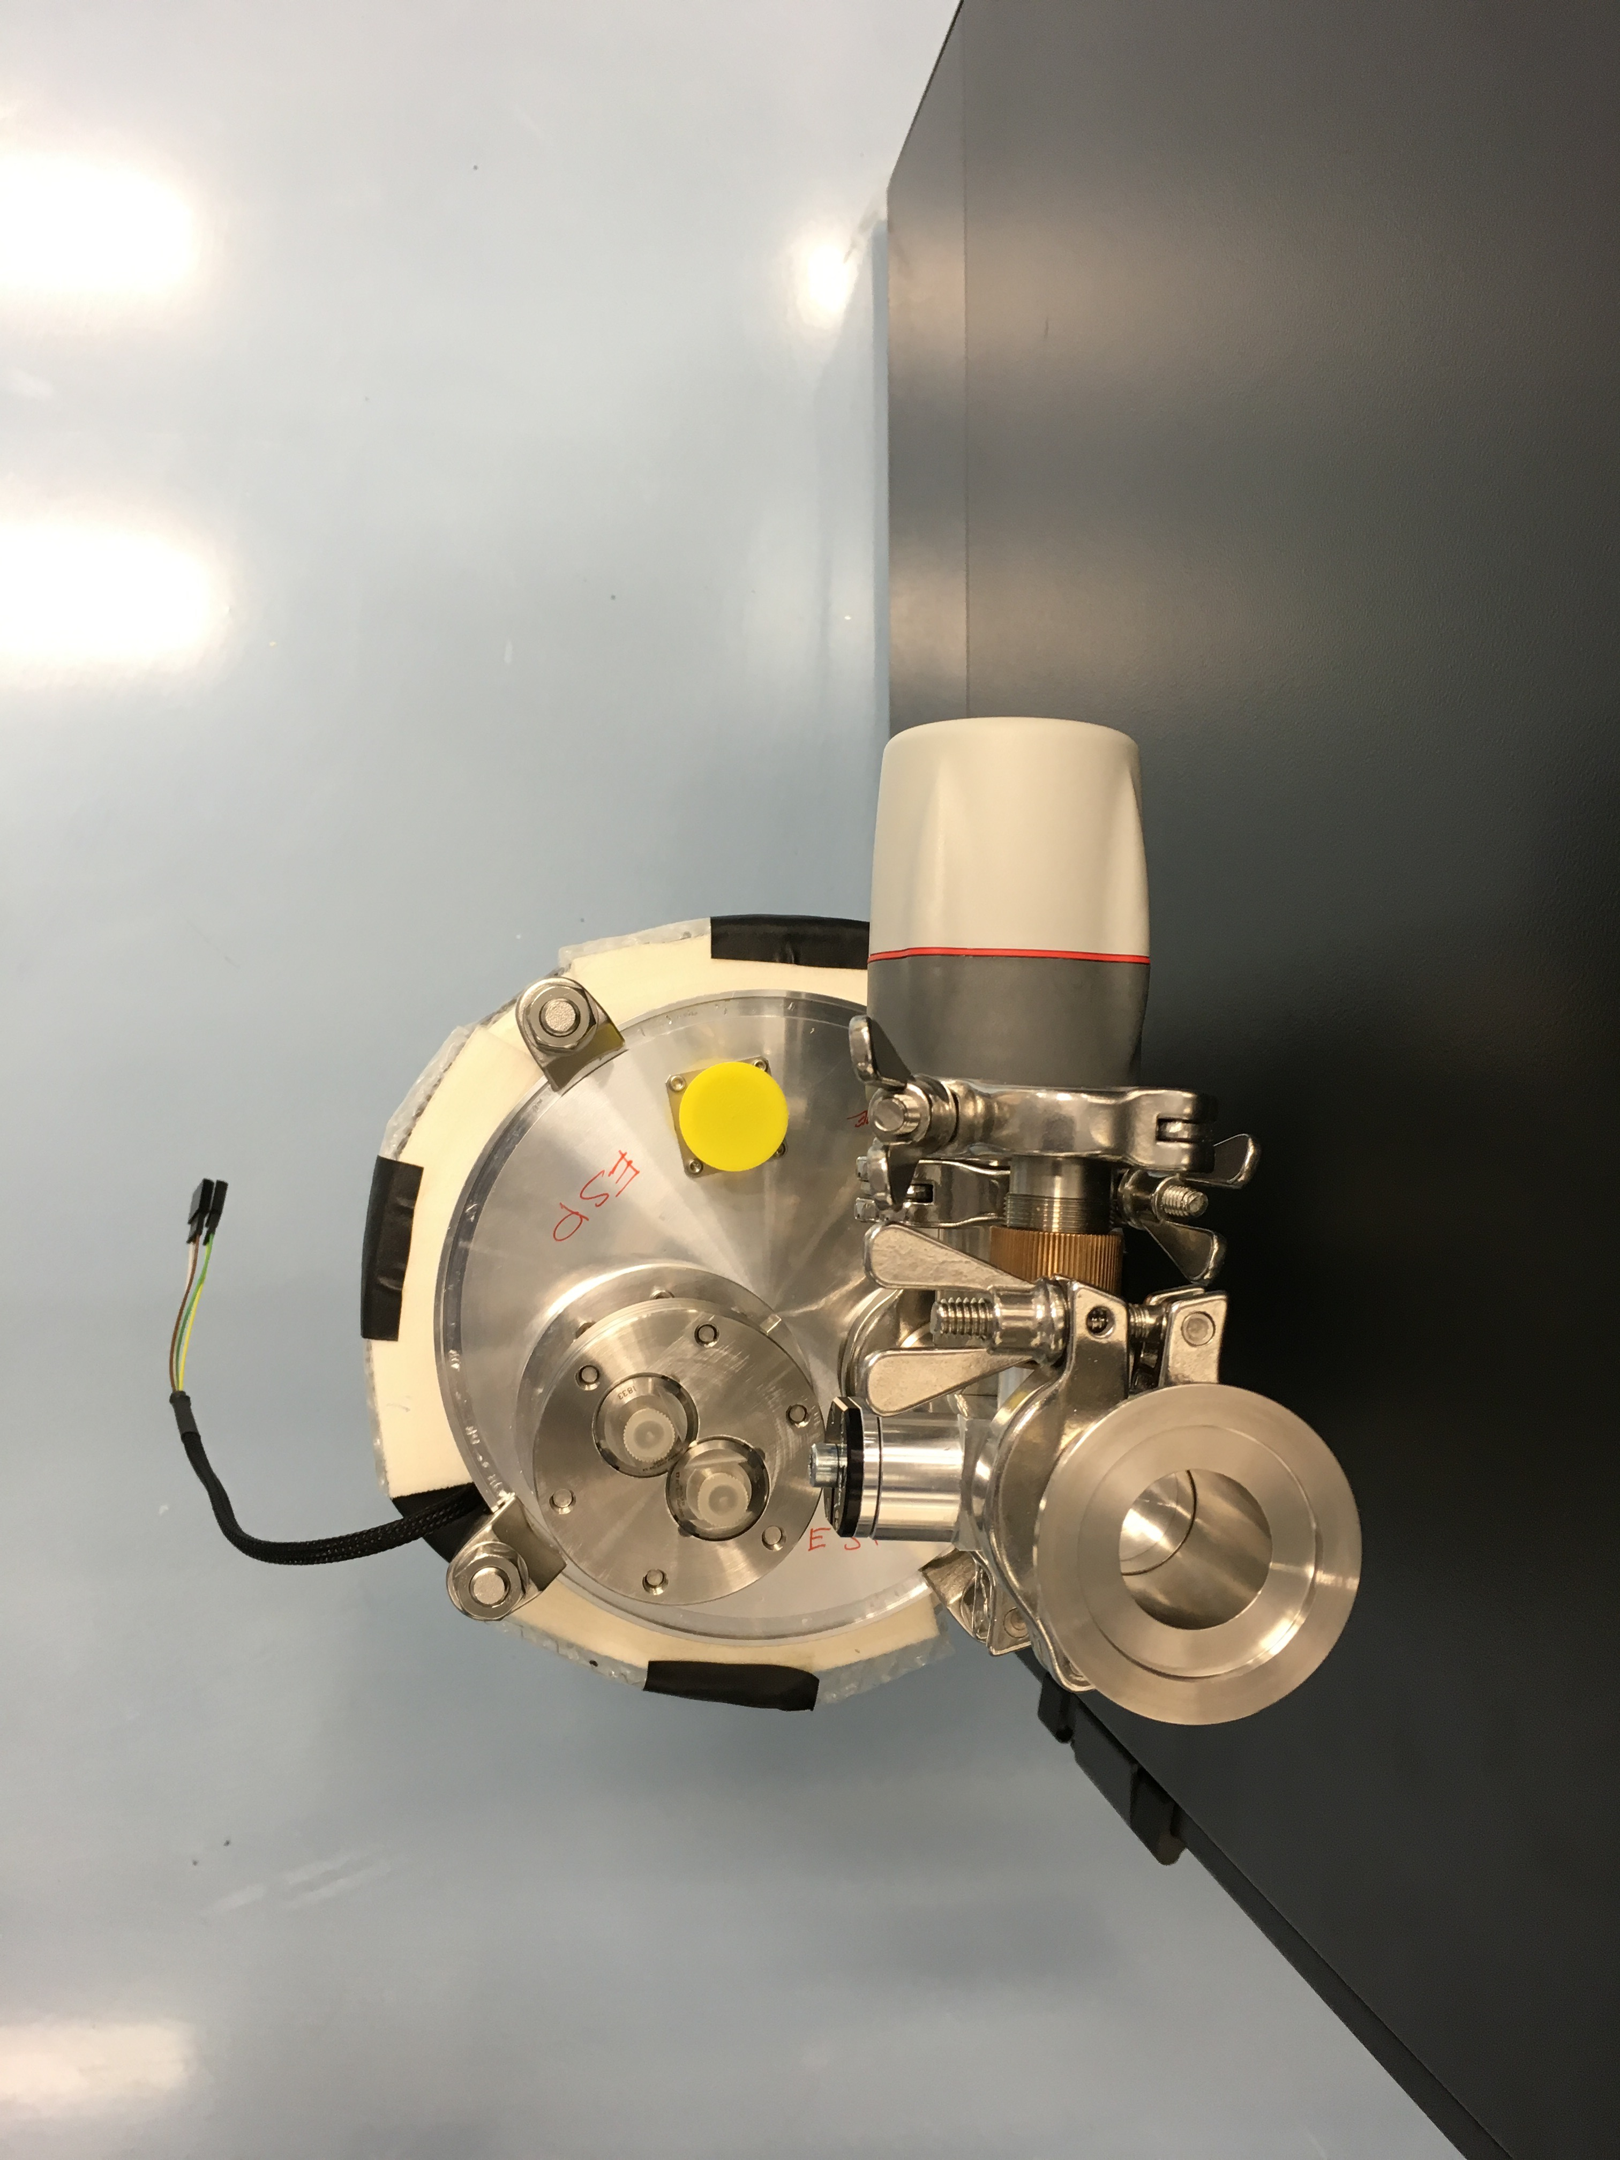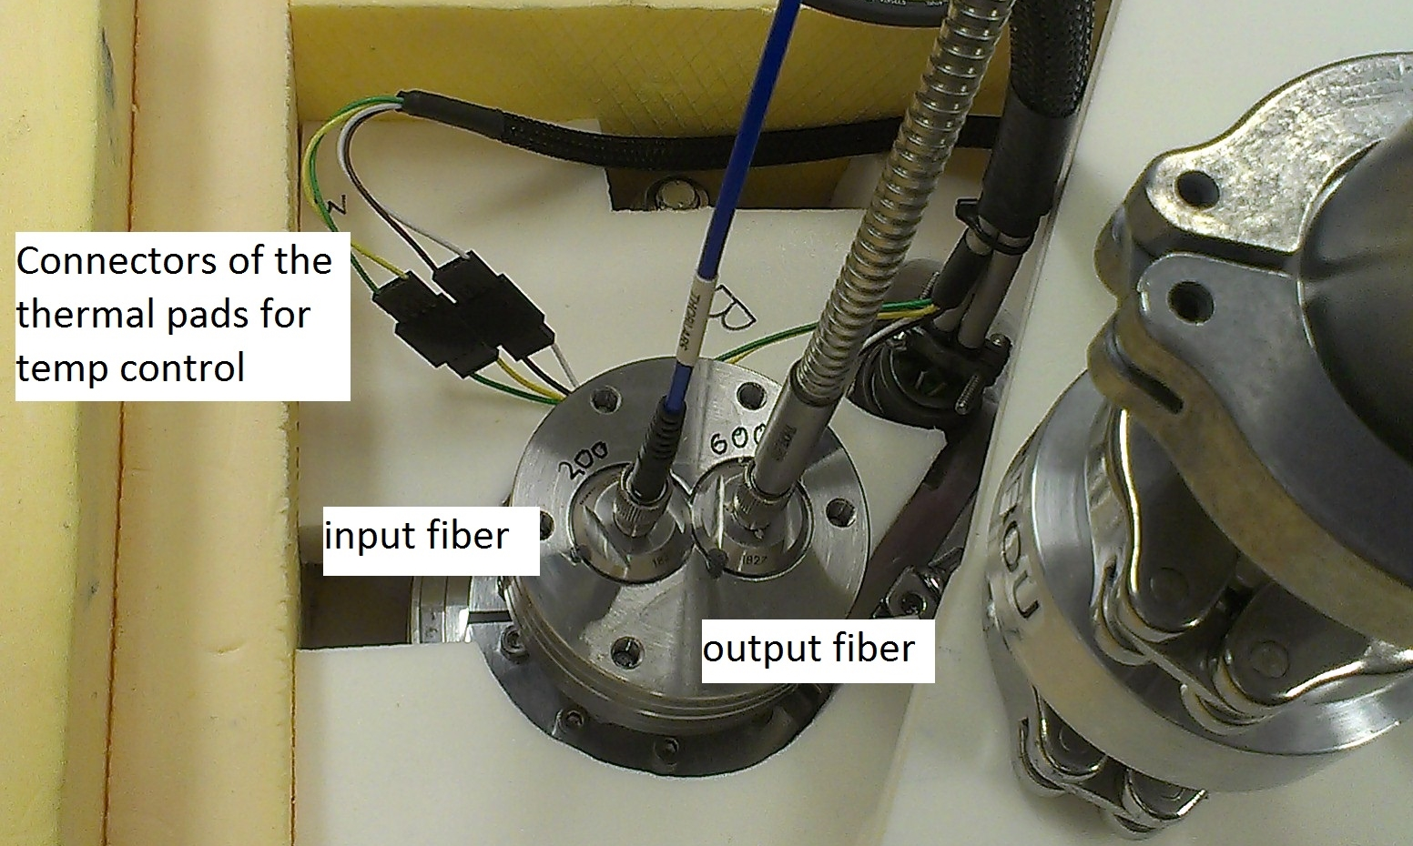

Figure 8: Top-view of the FPC
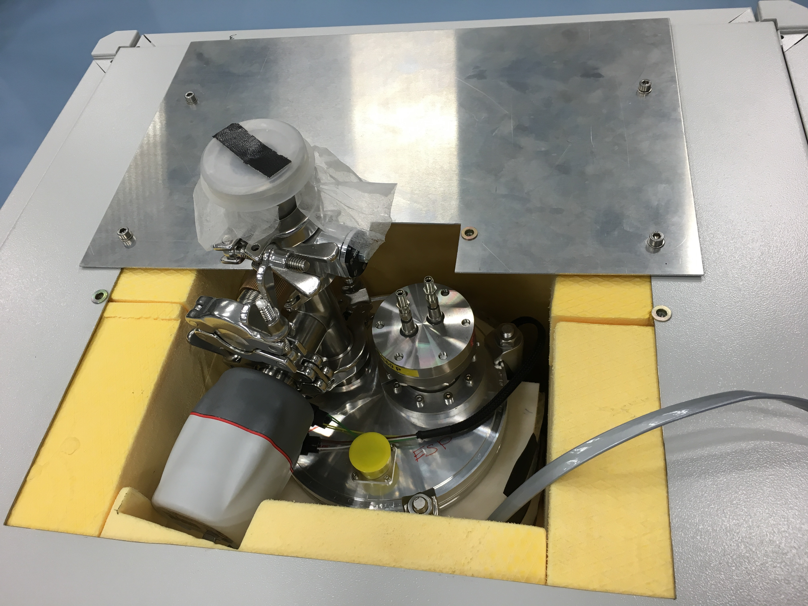

Figure 8: Connection of the Y-fiber on the Calibration Unit

Figure 10: Connection of the vacuum-gauge cable to the PLC on the Cryo- and Vacuum Control Cabinet

Operation
- Switch on the vacuum gauge controller monitoring
- Make sure the vacuum vessel is properly pumped (<1e-3 mB). The pump can be left on at all time or the manual valve can be closed and the module operated without pumping. Once pumped, close the valve, disconnect the vacuum pump and re-install the isolations.
- Switch on the temperature controller. The controller will start operating as soon as it is powered. The temperature set-point should be 5°C above the ambient temperature in the room where the FPC cabinet is located (CCL). The control must be PID and the parameters set to P = 100%, I = 5% and D = 100%. The temeprature should stabilize to the setting temperature within a couple of hours.
- Switch on the LDLS lamp at the back of the housing Turn on the LDLS by pushing the button on the left front side of the controller. From the moment the LDLS is turned ON, a comb of reference emission lines is produced by the RV reference module. However it will only reach the stability specification after the temperature is fully stabilized.
Reaching a stable temperature at the Fabry-Perot etalon level can take tens of hours (30-40h) depending on the starting temperature. The light flux from the lamp is part of the thermal balance of the Etalon and should therefore never be turned OFF if the RV module is operational.

Trouble shooting
There is no built-in health check in the RV reference module.
If the spectrograph sees light but the performance radial velocity stability is not good, start by checking that the temperature control is still running and performing. I.e the control sensor (on the vacuum vessel wall) will be spot-on on the temperature set point with frequent variations of a couple of milliK above and below set-point. The etalon temperature will be a few 10’s of milliK below set-point but with the same kind of stability as the control sensor. If the temperature loop is not working properly, this can be due the failure of the cable/connectors, thermal pads, controller or the silicon diodes used as temperature sensors.
If the spectrograph sees no light this is due to either the failure of the lamp or the failure of one of the fibers. The easiest way to track down the problem is to follow the light from the lamp. It is obvious to see if the lamp is bright of not. Up to the input fiber feedthrough on the vacuum vessel the light level can be checked by eye. From the output, there need to be a photometer showing at least some sensitivity beyond 900nm.
If light goes into the input feedthrough but nothing comes out, something must go wrong in the Fabry-Perot opto-mechanics. If this happens, advice on how to proceed should be requested from the Observatory of Geneva

Maintenance

Preventive Maintenance
No preventive maintenance is foreseen on the FPC apart from continuous flux monitoring by the pipeline and temperature monitoring by the ICS. Also, the ICS must be configured to never switch OFF the LDLS and give a warning if the lamp is not returning an ON signal.
The FPC is never re-evacuated.

Corrective Maintenance
The only possible corrective maintenance is the exchange of the LDLS lamp in case of failure. In this case following instructions must be followed (see Figure 10):
- Turn OFF the LDLS
- Disconnect all the cables on the back of the laser and the Xe-Source (cube) of the LDLS APART from the fiber connecting the two.
- Remove the laser and the Xe Source together with the fiber.
- Install the spare laser and Xe Source together with their fiber. (Never disconnect this fiber!)
- Reconnect all cables
- Switch ON the LDLS
- Send the replaced LDLS for repair to the company Mountain Photonics GmbH:

Mountain Photonics GmbH
Attn Mr. Michael Rotschädl
Robert-Bosch-Str. 10
86899 Landsberg am Lech
Tel: 08191-985199-33
Fax: 08191-985199-99
m.rotschaedl@mphotonics.de
www.mphotonics.de

Figure 10: LDLS lamp assembly in the Themal Cabinet

Cautions
In the following a list of important cautions and warnings is given:
- Never watch into the LDLS light output (or any fiber connected to it) when the LDLS is ON. Strong UV light may cause damage to the eyes!
- Never disconnect the fiber between the laser and the Xe Source (cube). Re-alignment and cleaning by an expert would be required.
- Never switch OFF the LDLS lamp when the FPC is in operation. Reaching a stable temperature at the Fabry-Perot etalon level can take tens of hours (30-40h) depending on the starting temperature. The light flux from the lamp is part of the thermal balance of the Etalon and should therefore never be turned OFF if the RV module is operational.
- Handle all fibers and fiber connection with care. Bending and stresses may damage the cables and fibers and prevent correct operation of the FPC.

